**OPIM 5641: Homework I**

**Linking to Web data and Conditional Formatting**

**Goal**

In this homework, you will learn:

1. How to load real-time data from the Web
2. How to parse the data from the Web into a user interface
3. How to use conditional formatting

**Purpose of the Spreadsheet**

In this spreadsheet, you will link to the real-time stock data available on CNN Money. Latest quotes from a list of stocks will be obtained in your spreadsheet and the total real-time value of a fictitious portfolio will be computed in real time. Conditional formatting will be used to highlight:

* If you have a gain or loss in each stock
* Whether you have a gain or loss in your total portfolio
* The current allocation of a stock as a percentage of the overall portfolio value

**Specifics**

The following functionality should be provided in the spreadsheet. When the user presses the **Data ⏵Refresh All** the latest stock quotes, their daily change and their daily percentage change have to be retrieved from the Website **money.cnn.com**. The performance data of your portfolio should be updated as well, and one should be able to instantly view the value of the portfolio. Conditional formatting will be used to highlight gains (in green) and losses (in red), and a data bar will show the percentage of a stock’s value proportional to the overall portfolio value. For the dollar changes (columns D and J in my example below), the cells need to be formatted according to the percentage change (see below). For the percentage changes (columns E and K), different shades of green and red need to be used as described below.

**Desired Result**

**Figure 1.** Example of Spreadsheet Layout

**Color Codes**

For the percentage changes, the following color codes need to be used:

* Dull red: daily changes of -0.1% or lower; portfolio changes of -3% or lower
* Bright red: daily changes between 0% and -0.1%; portfolio changes between 0% and -3%
* Bright green: daily changes between 0 and 0.1%; portfolio changes between 0 and 3%
* Dull green: daily changes over 0.1%; portfolio changes over 3%

Hint: Use the “New Rule” option under Conditional Formatting and then use “⏵Use a formula to determine which cells to format”

For the value changes (i.e., the columns “Change” and “Gain/Loss”) you use the same color as the respective percentage change. That is, in the example above, column D is formatted the same as column E, and the format of column J follows the same format as column K.

**Workbook Architecture**

A data source that retrieves the real time stock data can be constructed from the **money.cnn.com** Website. When you want to have a table of real time stock prices, use the URL:

[http://money.cnn.com/quote/quote.html?symb=<list_of_symbols_separated_by](http://finance.yahoo.com/quotes/%3clist_of_symbols_separated_by)_”+”>

For example, entering the URL:

<http://money.cnn.com/quote/quote.html?symb=IBM+MSFT+ORCL+MRK>

returns the following Web page.

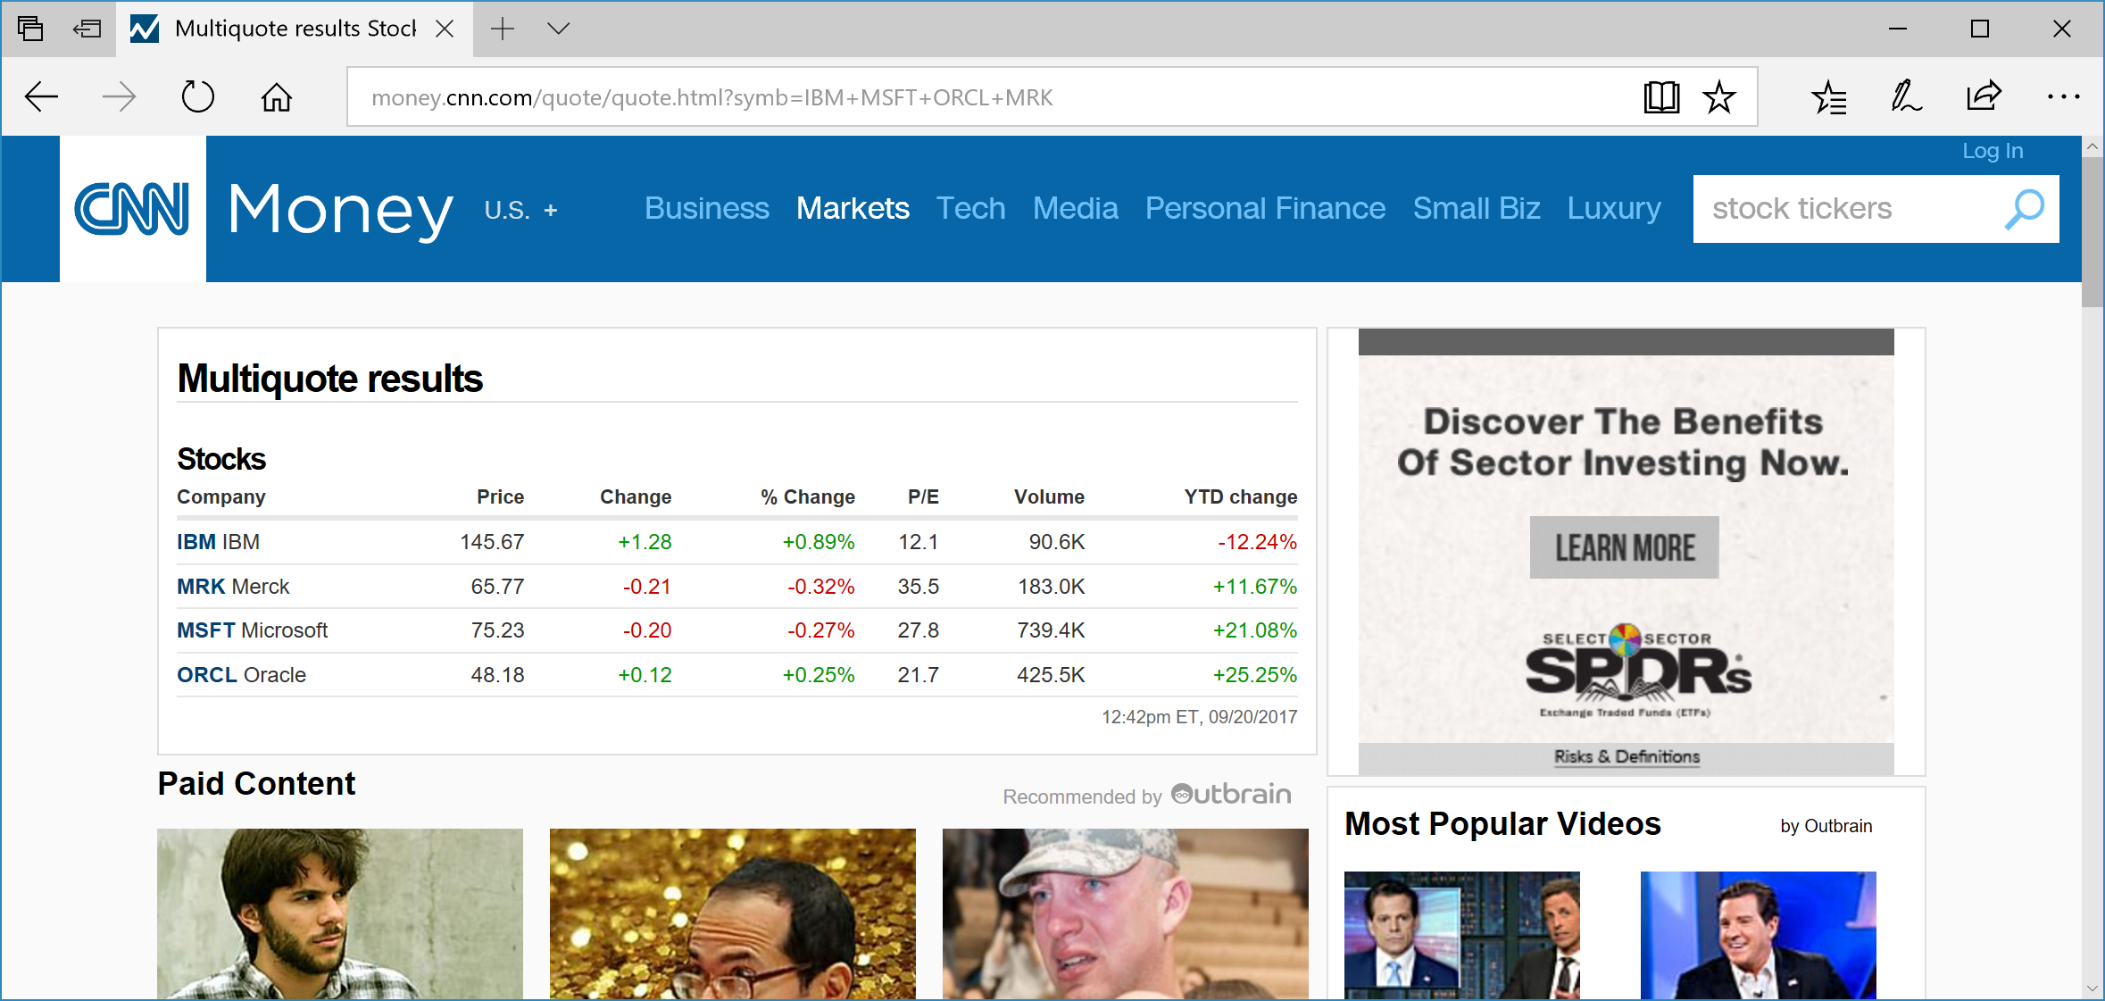

**Figure 2.** Getting a table with stock prices using Money.CNN.Com.

Next, press the Real-time tab and use this URL in your Data Connection of the Excel workbook (by doing a Copy-Paste of the URL from your Web browser).

The real time data will be retrieved in a “scratch sheet” that I called Weblink. Excel has problems parsing the data from **money.cnn.com** correctly and returns a lot of junk together with the data. For example, my Weblink sheet looks something like Figure 3.

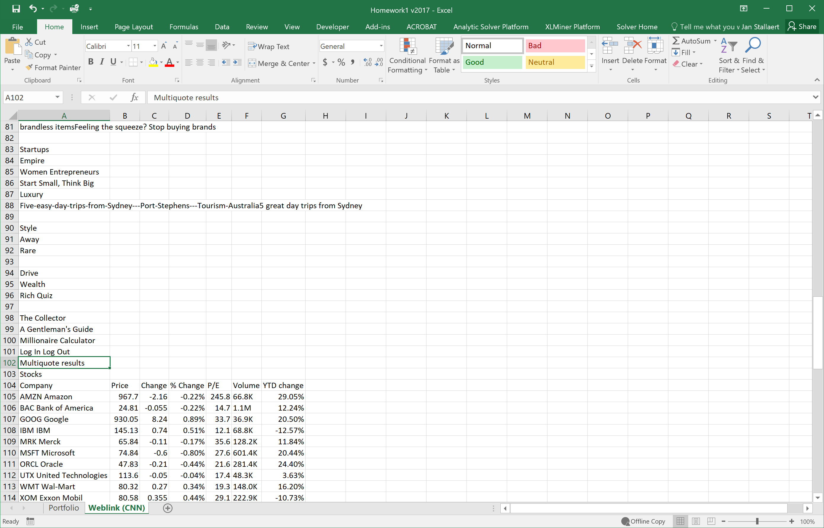

**Figure 3.** The “WebLink” Spreadsheet with the Results of the Web connection.

**Hint:** the trick with the offset as discussed in class may need to be used. You can, e.g., anchor on the word “Multiquote results” (use **MATCH** to find this row) preceding the quotes and then use the **OFFSET** function in the data table to extract the data.

**Computations**

The left part of the spreadsheet “Real time data” contains the data that links to the WebLink sheet, except for the column labeled value, which is the product of column G and column C.

The middle part of the spreadsheet (“Historical data”) does not contain formulas. The data here needs to be entered by the user.

The right part of the spreadsheet is all computed. The column “Gain/Loss” is just the difference between “Value” and “Total Cost.” The column “Gain/Loss %” is the ratio of “Gain/Loss” to the “Total Cost.” The “Portfolio Allocation” is the proportion of the stock’s “Value” (column F) with respect to the Total Portfolio value (cell F14). Highlight(bright green) portfolio allocation, the top 3 stocks in terms of highest percentage.

**Hints**

Useful Excel formulas for your workbook:

* if(condition, value_if_true, value_if_false): provides a logical test
* left(string,num): returns the first **num** characters from **string**
* mid(string,start_pos, len): subtracts the middle part of **string**, starting at position **start_pos**, it returns the next **len** characters, or until the end of string is encountered.

When the extracted data in the Weblink sheet is “shifting” when refreshing the data (i.e., the data of interest returns in different rows/columns from one refreshment to another), then the following Excel formulas are of interest:

* match(<specific search string>,range): finds the row/column that marks the (approximate) start of the data of interest;
* offset(cell,offset_rows,offset_columns): adds offset_rows to the row of “cell” and offset_colmns to the column of “cell”.

**Notes**

For uniformity and ease of grading, please use the following stock symbols in your homework: IBM, ORCL, MSFT, XOM, MRK, AMZN, GOOG, UTX, WMT, BAC, FB and the same data as in “Historical Data” in Figure 1.